There is a Many-to-Many relationship between the Director table and the Movie table.
Both sets of tables here have the data stored in ways that break normalisation rules and therefore will cause problems the way SQL works. One version has multiple values in a single column the other has duplicate Primary keys.
Ideally a One -to-Many relationship between Director and Movie would be great but this is not possible as some movies have more than one director involved!
DirectorID | Name | MovieID
1 | Gina Bythewood | 8
2 | Quentin Tarentino | 5
3 | Robert Rodrigez | 5
4 | Amy Heckerling | 2,7

DirectorID | Name | MovieID
1 | Gina Bythewood | 8
2 | Quentin Tarentino | 5
3 | Robert Rodrigez | 5
4 | Amy Heckerling | 2
4 | Amy Heckerling | 7

SQL uses the relationship created between a single Primary key and a Foreign key to find information stored in different tables.
For example to display information from both tables it needs to know how to link the tables:
i.e. It needs to use values in the MovieID column that are shared with The DirectorID column in both tables.
So if we wanted to find out who directed Four Rooms the SQL engine would not be able to make a match between the two tables as in the first format the Movie table has two DirectorID values listed for Four Rooms and in the second format we have introduced duplication in the table.
In this case we have to introduce a small bridging table to house the foreign keys from Director and Movie to avoid either duplication of primary keys or multiple values in one column as both of these break normalisation rules and would cause problems using SQL in a RDMS.
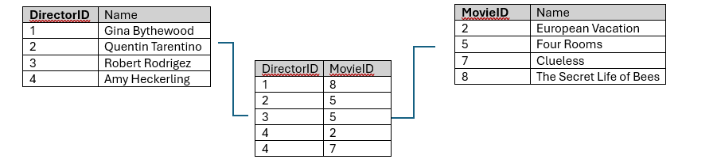
Note: There is a similar issue between the Character, Actor and Movie tables. One actor van play many characters but a character can appear in more than one movie. Think Star Wars! Luke Skywalker and Han Solo.

